TITLE OF PAPER (Times New Roman, 16 pt., bold, centered)
First and last name of author – first and last name of co-author(s) (without titles) (Times New Roman, 14 pt., bold, centered)

Abstract
The text of abstract – 150 - 200 words ! (Times New Roman, 12 pt. , alignment in block, spacing 1,5) xxxxxxxxxxxxxxxxxxxxxxxxxxxxxxxxxxxxxxxxxxxxxxxxxxxxxxxxxxxxxxxx
xxxxxxxxxxxxxxxxxxxxxxxxxxxxxxxxxxxxxxxxxxxxxxxxxxxxxxxxxxxxxxxxxxxxxxxxxxxxxxxxxxxxxxxxxxxxxxxxxxxxxxxxxxxxxxxxxxxxxxxxxxxxxxxxxxxxxxxxxxxxxxxxxxxxxxxxxxxxxxxxxxxxxxxxx
Key words: key word, key word, key word (3-5)
JEL Code: JEL Code, JEL Code, JEL Code (2 – 3)

Introduction (Times New Roman, 14 pt., bold)
Text of introduction (Times New Roman, 12 pt. , alignment in block, spacing 1,5) xxxxxxxx
xxxxxxxxxxxxxxxxxxxxxxxxxxxxxxxxxxxxxxxxxxxxxxxxxxxxxxxxxxxxxxxxxxxxxxxxxxxxxxxxxxxxxxxxxxxxxxxxxxxxxxxxxxxxxxxxxxxxxxxxxxxxxxxxxxxxxxxxxxxxxxxxxxxxxx

1 Title of chapter (Times New Roman, 14 pt., bold)
The main text. (Times New Roman, 12 pt., alignment in block, spacing 1,5) The extent of the paper can be 6-10 pages. The main text. The main text. The main text. The main text. The main text. The main text. The main text. The main text. References in text should have this form (surname, year), for example: (Friedman, 1970).
The main text. The main text. The main text. The main text. The main text. The main text. The main text. The main text.

  - Title of subchapter (Times New Roman, 12 pt. bold)
The main text. (Times New Roman, 12 pt., alignment in block, spacing 1,5) The main text. The main text. The main text. The main text. The main text. The main text. The main text. The main text. The main text.
The main text. The main text. The main text. The main text. The main text. The main text. The main text. The main text.

Fig. 1: Title of figure (Times New Roman, 12 pt. bold)
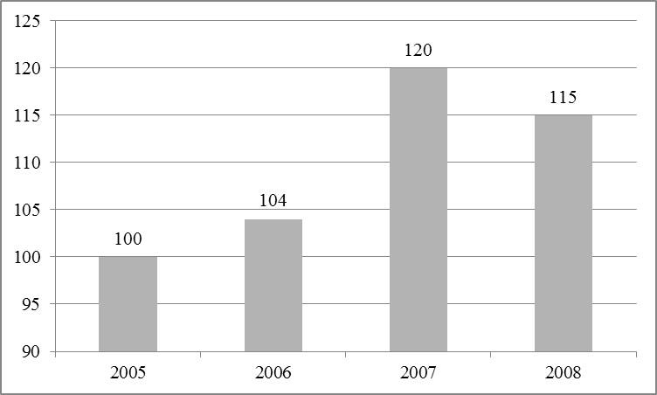
Source: xxxxxxxxxxxxx
The main text. The main text. The main text. The main text. The main text. The main text. The main text. The main text.

Tab. 1: Title of table (Times New Roman, 12 pt. bold)
10 pt. Times New Roman
Source: xxxxxxxxx
The main text. The main text. The main text. The main text. The main text. The main text. The main text. The main text.
For writing equations, use this generator of equations (it is from Word 2003, don´t use generator from Word 2007 or 2010).
$P=a−b⋅Q$ (1)
The main text. The main text. The main text. The main text. The main text. The main text. The main text. The main text.

Conclusion (Times New Roman, 14 pt., bold)
The main text. (Times New Roman, 12 pt., alignment in block, spacing 1,5) The main text. The main text. The main text. The main text. The main text. The main text. The main text.
The main text. The main text. The main text. The main text. The main text. The main text. The main text. The main text.

Acknowledgment (Times New Roman, 14 pt., bold)
If any

References (Times New Roman, 14 pt., bold)
10 – 15 references – no more! All citations in the text and all references must meet APA styles (American Psychological Association – more information http://www.apastyle.org/)! Please, use automatic citation maker for citation and references: automatic APA citation maker. (http://citationmachine.net/index2.php?reqstyleid=2&newstyle=2&stylebox=2) Minimum 5 references have to be from Web of Science Database.

Contact (Times New Roman, 12 pt., bold)
First and last name of author (Times New Roman, 12 pt., spacing 1,5)
Institution
Full address of institution
Mail

First and last name of co-author (s)
Institution
Address of institution
Mail

Footnote.

